The Birth of Rome

According to legend, twin brothers, Romulus and Remus, founded Ancient Rome.
The Roman writer, Marcus Terentius Varro, decided, mostly from guesswork, the date was 21 April 753 BCE. Tarquin the Proud was the last king of Rome and when he was expelled in 510 BC, the Republic was founded. It was by tracing Tarquin’s predecessors back 300 years that Varro reached the widely accepted date.

The Legend
The legend of Romulus and Remus begins with King Numitor and his daughter Rhea Silvia. King Numitor's brother, Amulius, deposes him and forces Rhea to become a Vestal Virgin to prevent her from having children. Mars, the god of war, impregnates her when she was held captive. Amulius learns of the birth of the twins and has them thrown into the Tiber River. They survive and wash ashore on Palatine hill. A she-wolf suckles the boys until a shepherd named Faustulus finds and raises them.

Later they became leaders of a band of shepherd warriors. After learning of their true identity, the brothers attack Alba Longa, kill Amulius and restore their grandfather, Numitor. Then they decide to found a city at Palatine but argue over where to build it. Romulus builds a wall on Palatine Hill and to mock him Remus jumps over the wall. This act enrages Romulus and he kills Remus. The city is named Rome after Romulus.

The Greek Legend
The second legend tells of the mythical Trojan Aeneas. He founds Lavinium and his dynasty leads to the birth of Romulus and Remus. Aeneas is the only Trojan hero to survive the Greek destruction of Troy. He escapes to the small city-state. There are more myths as shown in Table 1 below.

Table 1
Myths Through the Centuries
Origin | Century | Myth
Greek historians | Eighth century BCE | The mythical Trojan Aeneas founded Lavinium and started a dynasty that would lead to the birth of Romulus and Remus centuries later.
Greek historians | Fifth century BCE | Aeneas settled at Rome, when it was a small city-state.
Widely accepted by the Romans | Fourth century BCE | According to the legend, Romulus and Remus were the sons of Rhea Silvia, the daughter of King Numitor of Alba Longa.
Roman scholar Varro | First century BCE | 21 April 753 BCE, Romulus and his twin brother Remus, found Rome where they were suckled by a she-wolf.
The Roman poet Virgil | First century BCE | The Aeneas myth in his epic poem, The Aeneid, which told of Aeneas’s journey to Rome.
Greek historians | Unknown | Rome was named after Roma, a woman who travelled with Aeneas and other survivors from Troy. She stranded the survivors on the banks of the Tiber River by burning the Trojan ships.
Archaeologists | Present day | The name of the famous city suggests it came from Rumon, the ancient name for the Tiber River, a place-name derived from an Etruscan word.
(Mark, 2009) (Cavendish, 2003) (History.com, 2009)

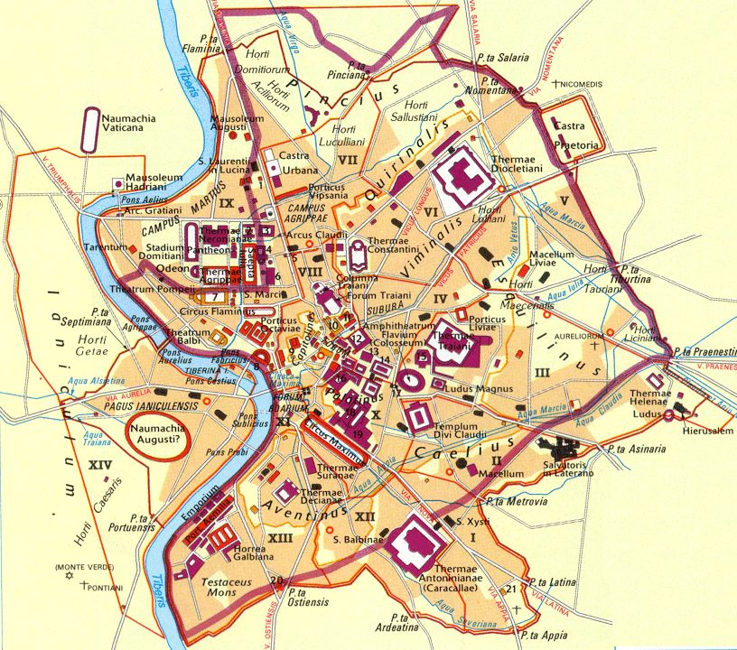
What We Know
Rome was prospered by trade via the Tigris River and was heavily influenced by Greek culture.

From the Greeks, Romans obtained literacy, religion and architecture. From the Etruscans, Romans modeled their urban luxury, trade practices and winemaking skills.

Borrowing and improving upon the skills and concepts of other cultures, Rome grew from a trading town to a prosperous city between the eighth and sixth centuries BCE. Ultimately though, war gave Rome its power.
Figure 1 map of Rome in ancient times,”During the Empire” from the-colosseum.net/history/maps.htm

Bibliography

Cavendish, R 2003, The Foundation of Rome, History Today, viewed 25 October 2017, http://www.historytoday.com/richard-cavendish/foundation-rome

History.com staff 2009, Rome Founded, History.com, A+E Networks, viewed 22 October 2017, http://www.history.com/this-day-in-history/rome-founded

Mark, J.J 2009, Ancient Rome, Ancient History Encyclopedia, viewed 25 October 2017, https://www.ancient.eu/Rome/

